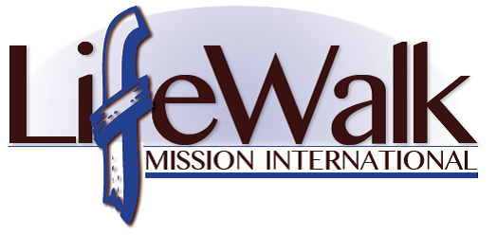
Mission Awareness Webinar Sessions

Do you have a heart for people around the world? Have you ever said “I want to go on a mission trip” but find it difficult to plan ahead for such an adventure? With all the responsibilities pulling at you in your personal life, do you find it a struggle to put things in proper order and aren’t able to take a moment for an international expedition? Can’t find the funds necessary to travel to the ends of the world? Look no further, LifeWalk Mission International will host a free webinar/conference call each month to provide you with spiritual applications to overcome those tough questions.

The Benefits of the Webinar/Conference Call
- A simple one-hour dialogue with the Executive Director of LifeWalk Mission International
- Spiritual encouragement/support to ease your mind about international mission work
- Fundraising tips and tools to help you raise sufficient revenue for your future travels
- Access to the web/conference call via a toll free 800 number
- Provide details of upcoming short-term mission trips offered by LifeWalk Mission International
- Best of all….IT’S FREE!!

FAQs
Question: Do I have to attend all the webinar session?
Response: No, but the more you engage in the sessions, the better you become equipped
for international travel!

Question: What kind of equipment should I use for the webinar?
Response: We strongly suggest using a laptop that includes Microsoft PowerPoint software.
It would be wise to ensure you have strong Wi-Fi signal in your home/place of
residence so that you won’t lose any signal when we are discussing important
matters on the conference call.

When
Each monthly web/conference call will take place every third Monday of each month. From-time-to-time, the organization will change the meeting dates when the staff of LifeWalk Mission Intl. is out of the country on a mission trip. We will alert everyone in advance when this occurs.

What do I need to do?
Simple, contact LifeWalk Mission International via e-mail and tell us that you want to partake in the Mission Awareness Webinar Sessions. Leave us your full name, phone number and primary e-mail address so that we can send you updates and conference call instructions. Also, please tell us that you want to subscribe to our quarterly e-newsletters – this steady communication will give you more insight about our ministry service.

LifeWalk Mission International Email: jlwarrenii@kateibo.com
P.O. Box 712 Web: www.lifewalkmission.org
Mableton, Georgia 30126 Phone: (866) 886-2641

